Sufficient Output

Q1

b1:

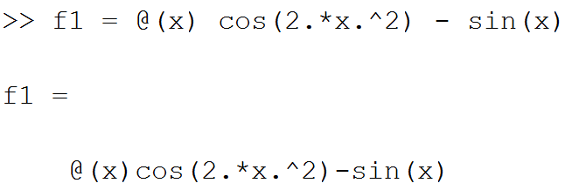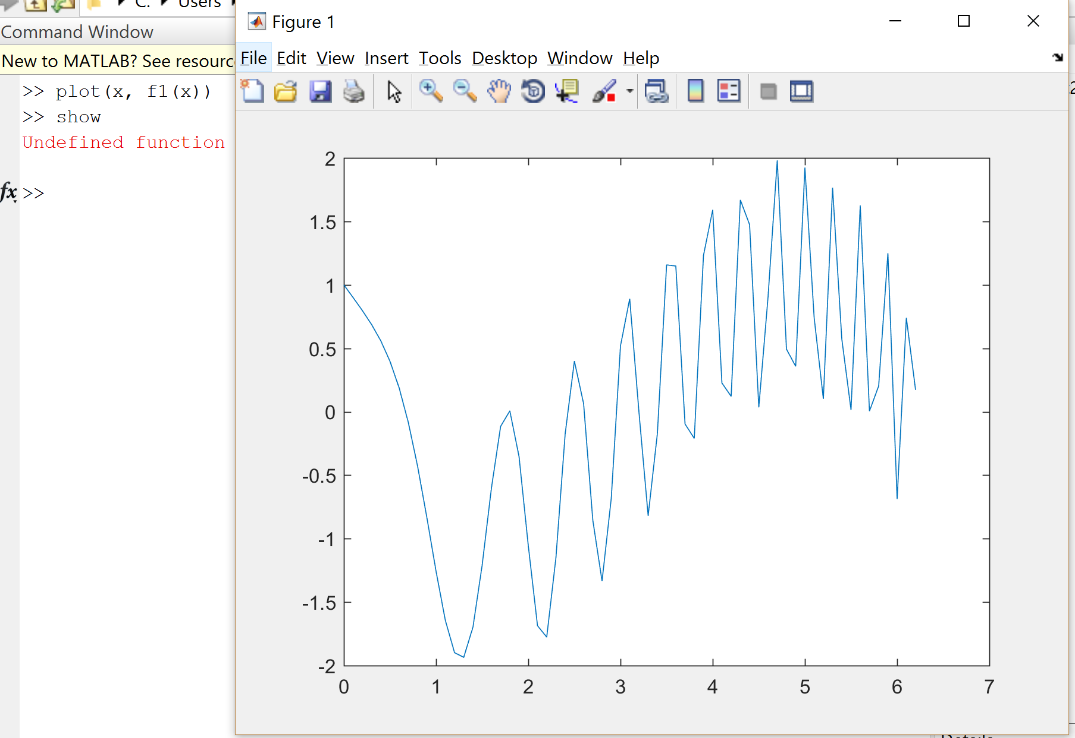

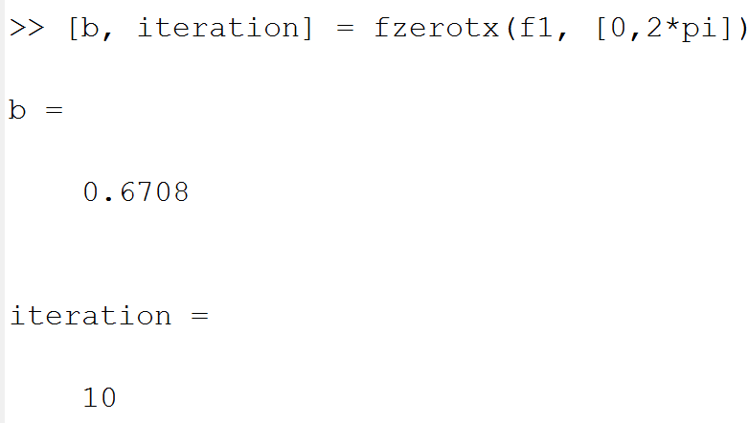

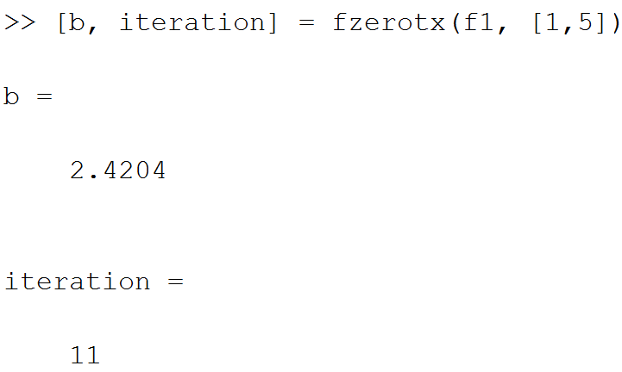

Q1 b2

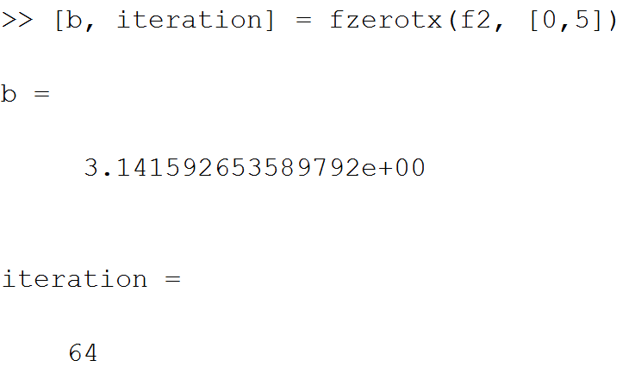

Q1b3

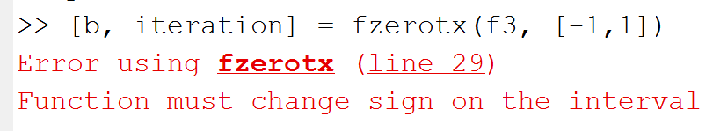

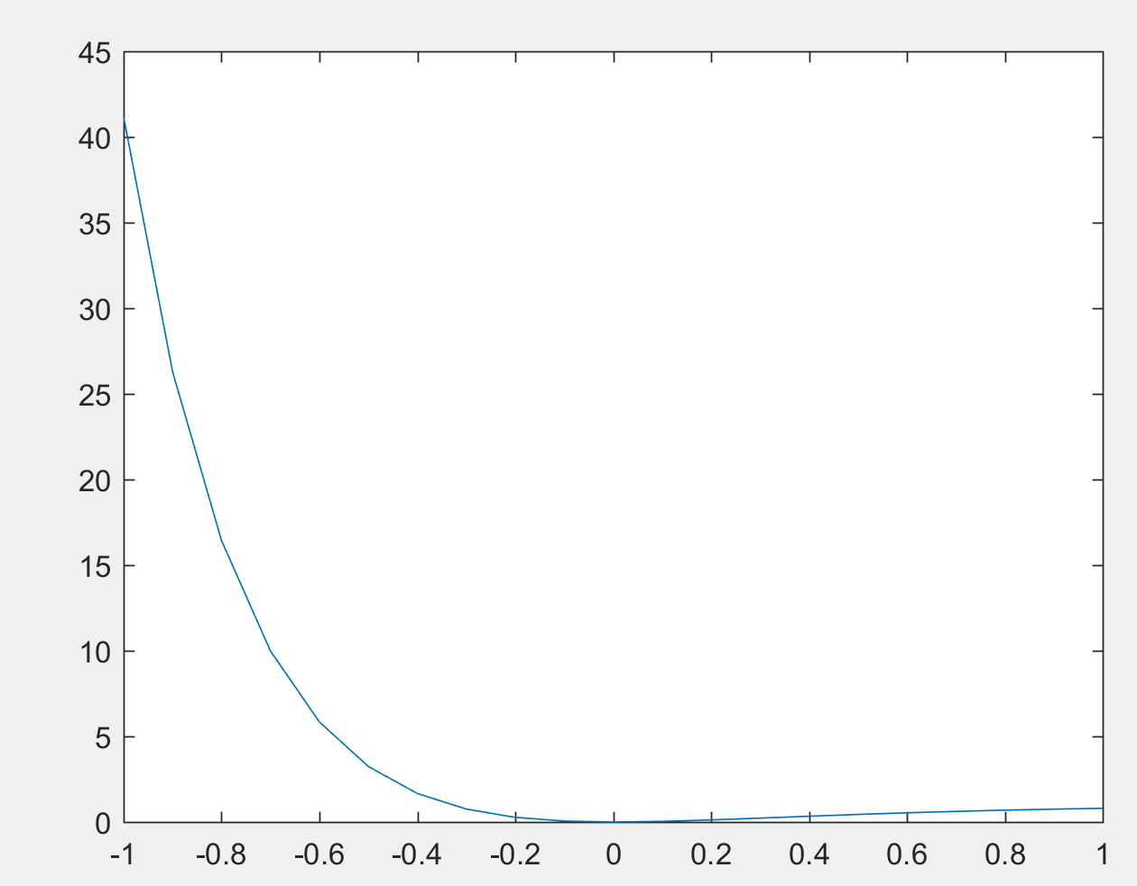

Q3c Sufficient Output (convergence history is referred as residual history)

Initial guess x1 = [1.2, 2.5]

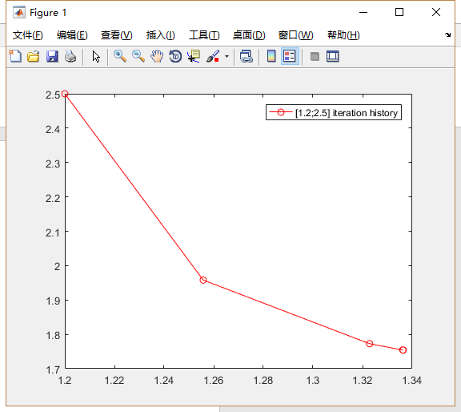

**Graph Index: Q3c1**

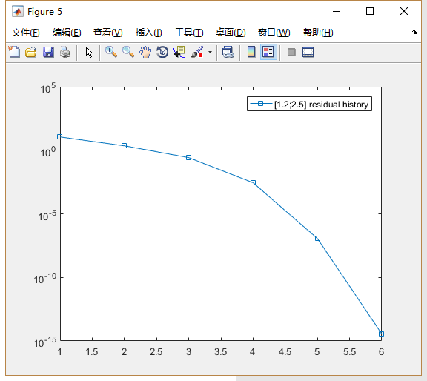

Initial guess x2 = [-2, 2.5]

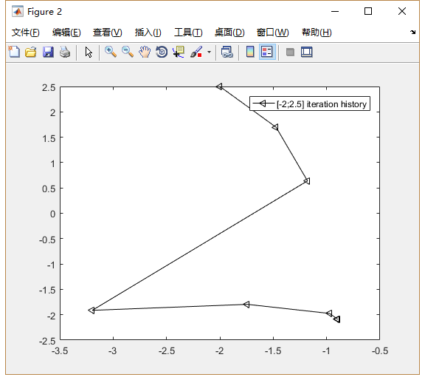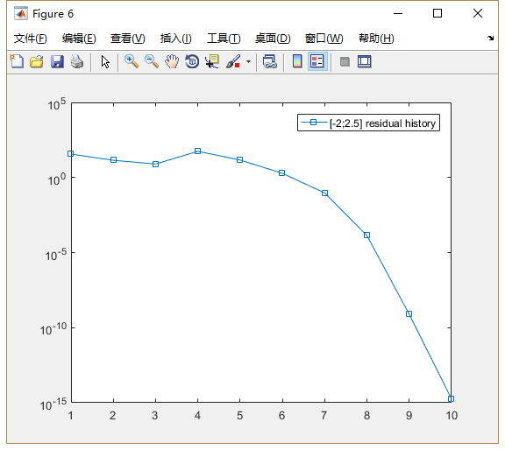

**Graph Index: Q3c2**

Initial guess x3 = [-1.2, -2.5]

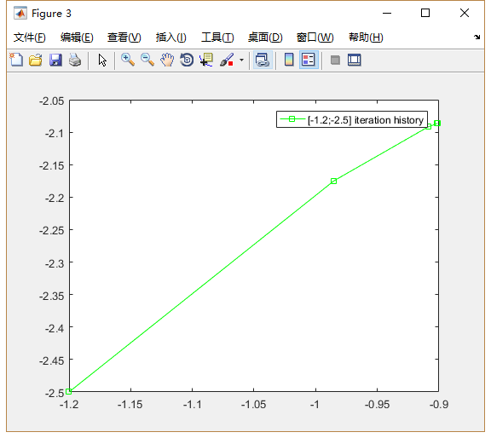

**Graph Index: Q3c3**

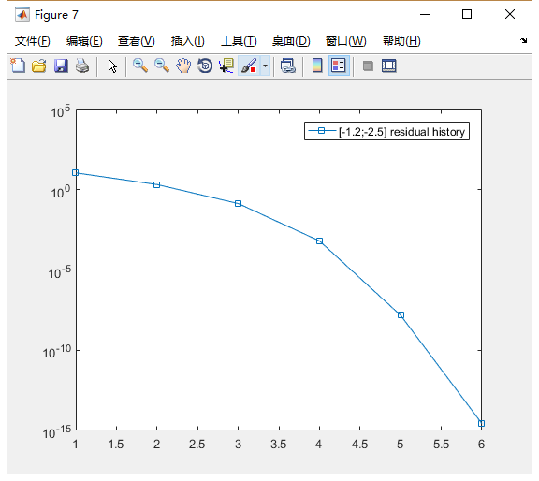

Initial guess x4 = [2, -2.5]

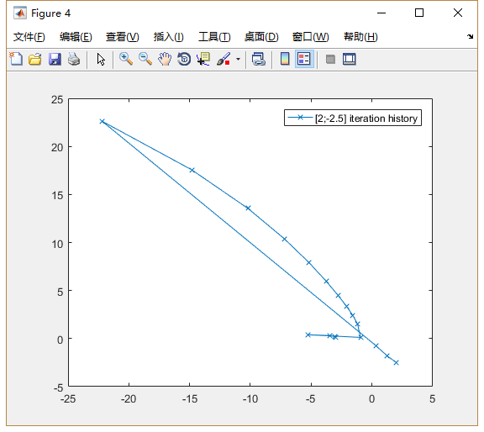

**Graph Index: Q3c4**

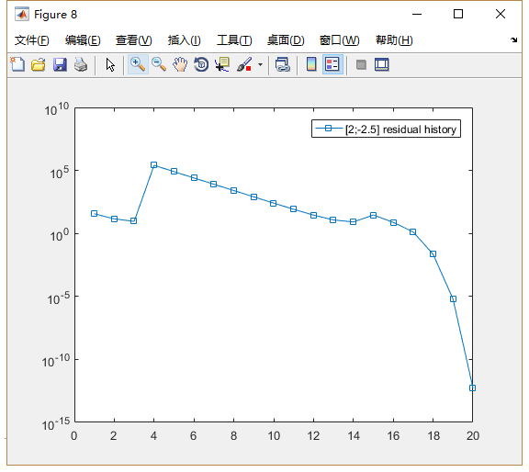

The plot of iteration history on the contour graph of the system of equation

For initial guess x1 = [1.2, 2.5], x2 = [-2, 2.5], x3 = [-1.2,-2.5]

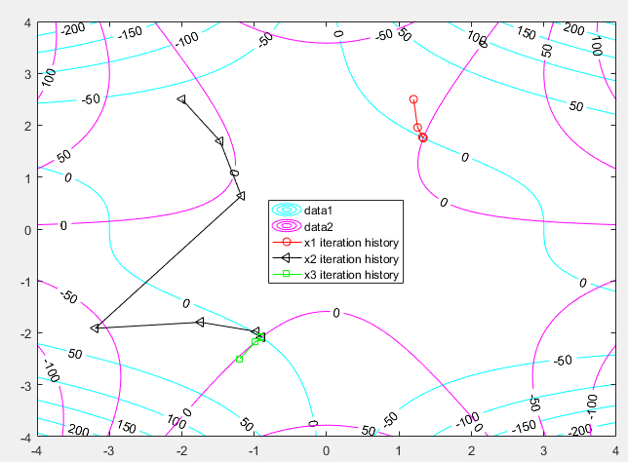

**Graph Index: Q3c5**

For initial guess x4 = [2, -2.5]

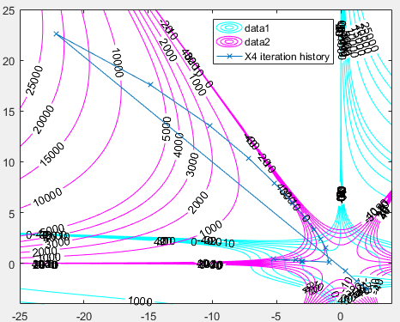

Contour of equations system at level 0 with 4 initial guesses

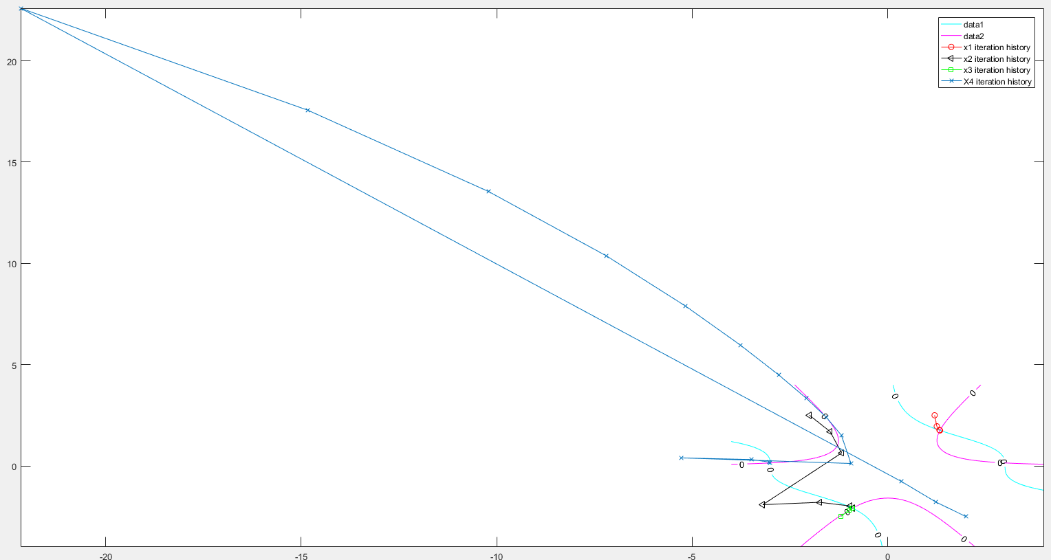

A Close up of x1, x2, x3 initial guess

**Graph Index: Q3c6**

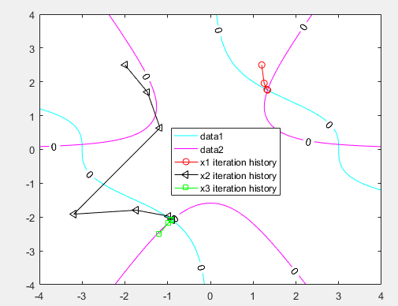

Q4

A

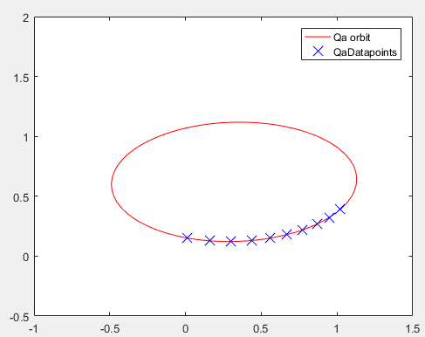  
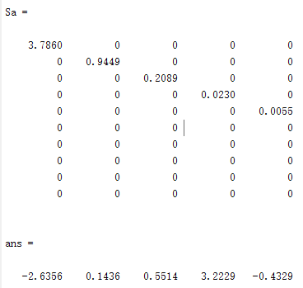

Note: Because we will using $x^{2}=by^{2}+cxy+dx+ey+f$ to find the constant, so the row in $ans$ is correspond to the value of [b c d e f], with a = -1. Whereas Matrix A = in the form $[y^{2}x*y x y 1]$

B Qa means the original data and orbit. Singular values of Matrix A and constant for equation is recorded above. The original orbit and its data points is in red color.  
Here we only show the perturbed data’s orbit, constant and their singular value for A.   
 